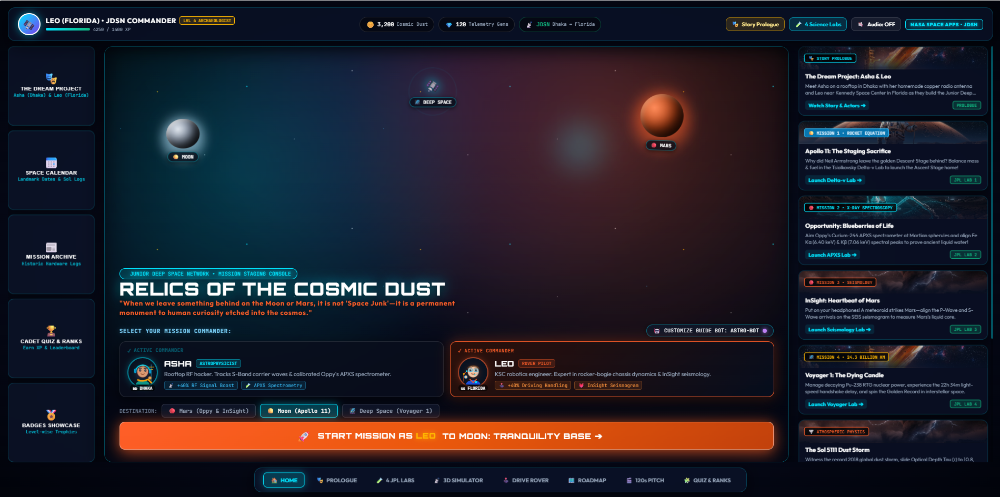

- Skip this section red marked (left and right side)

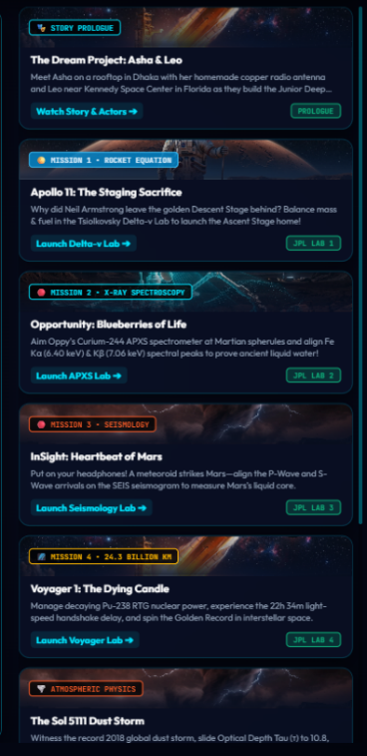
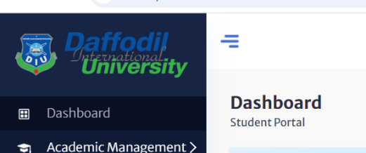
Use sidebar in the left side.


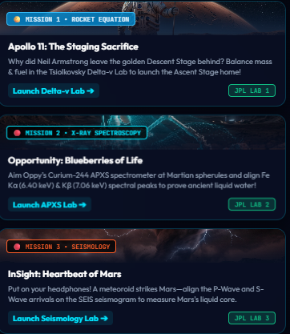 3. After clicking these , it jump into the game but we want story or history in these section .

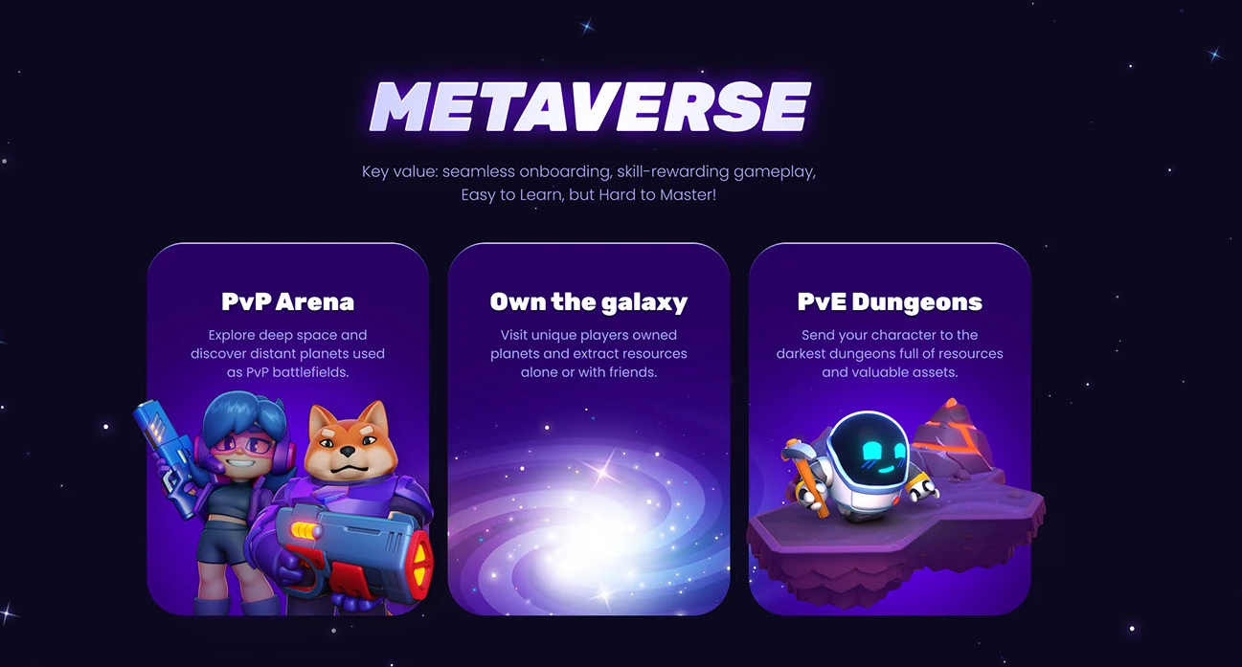

4.news/stories will be like this .
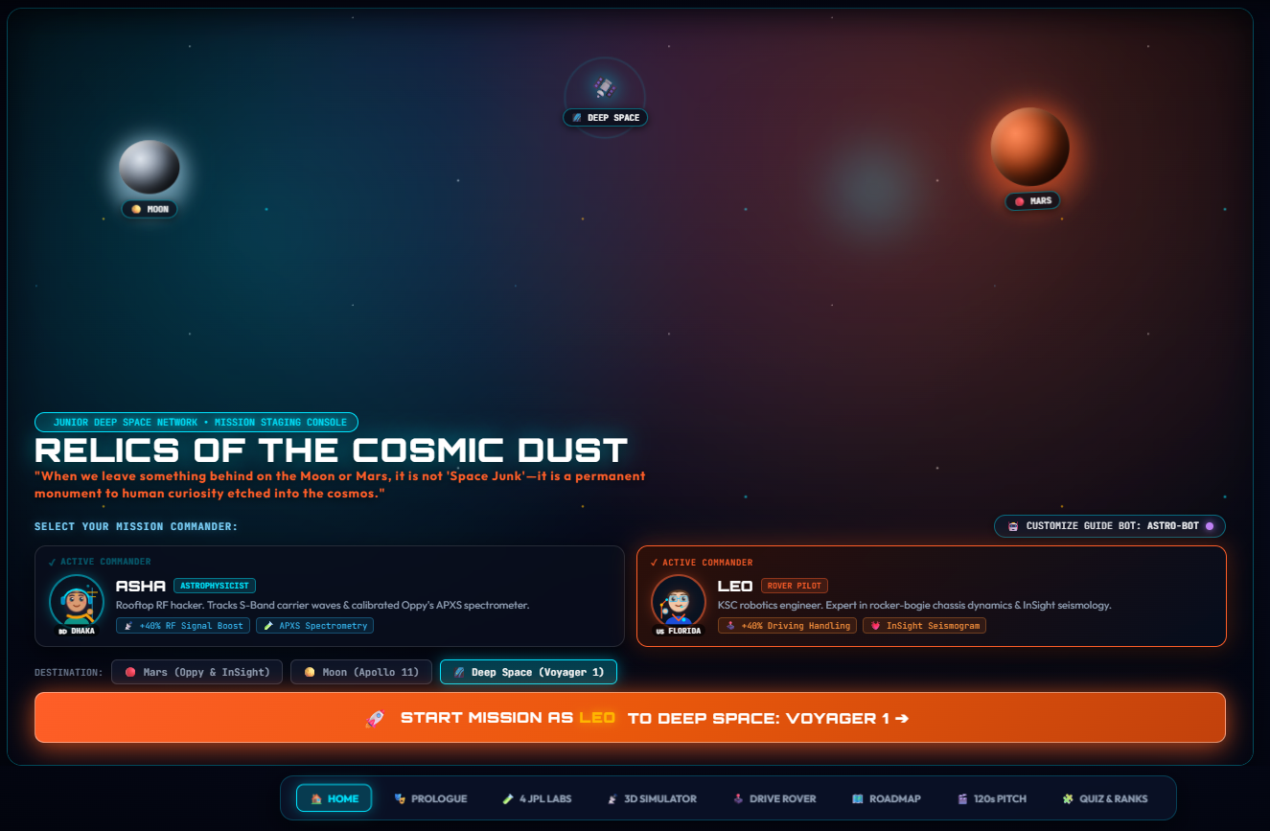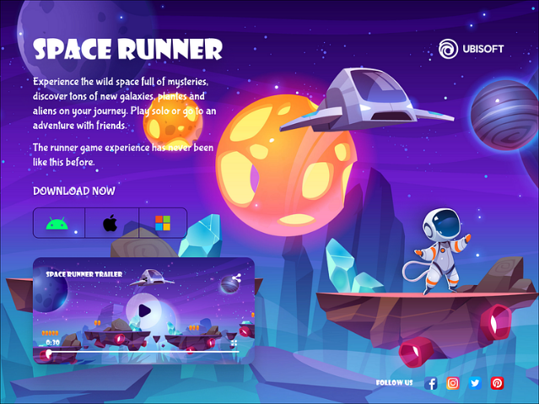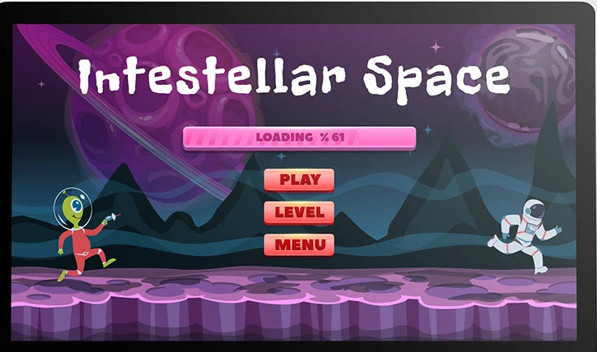
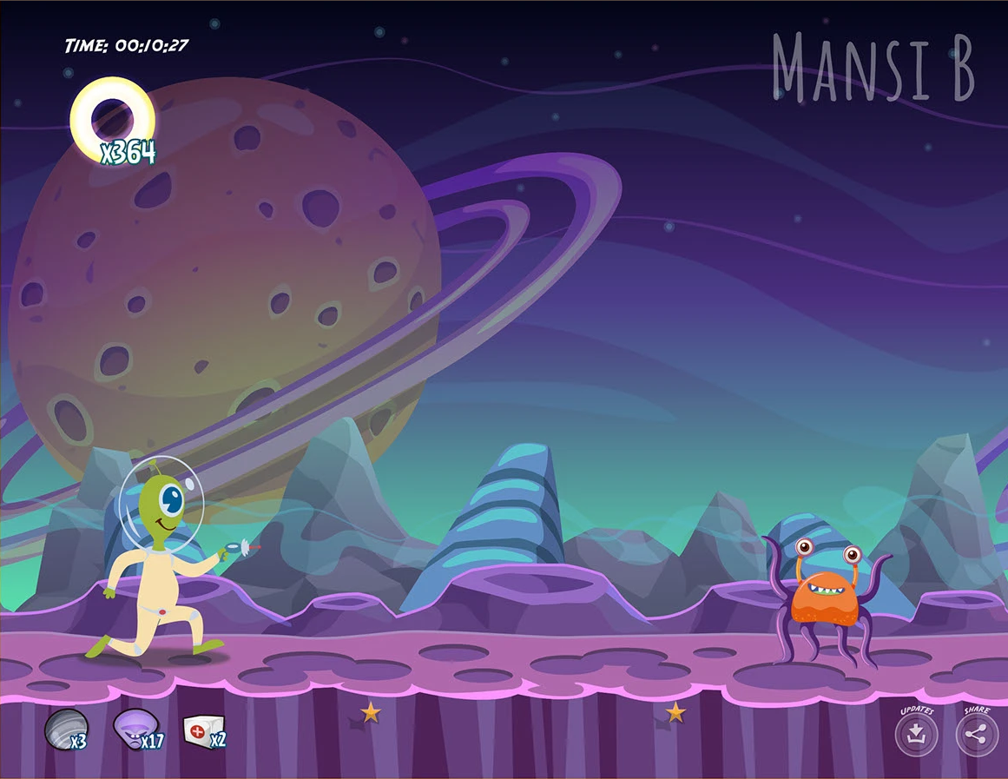

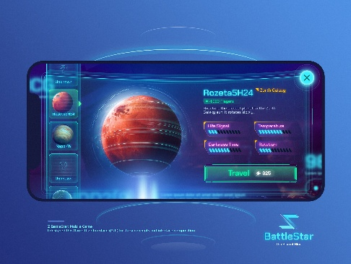
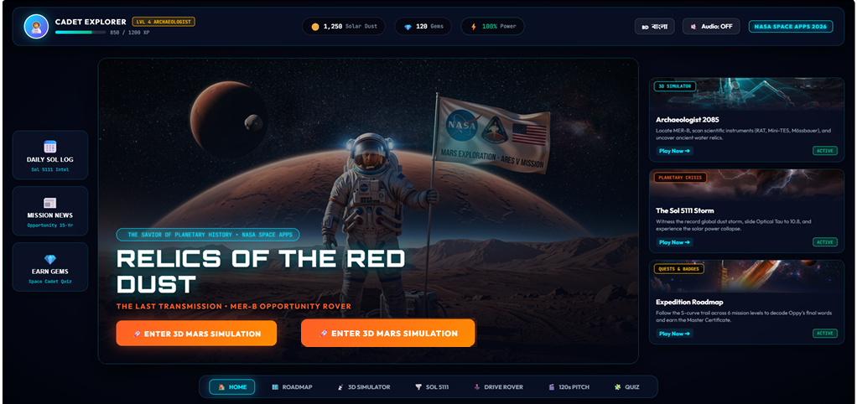
5. two simple option (1.explore the moon,,2.explore the mars)

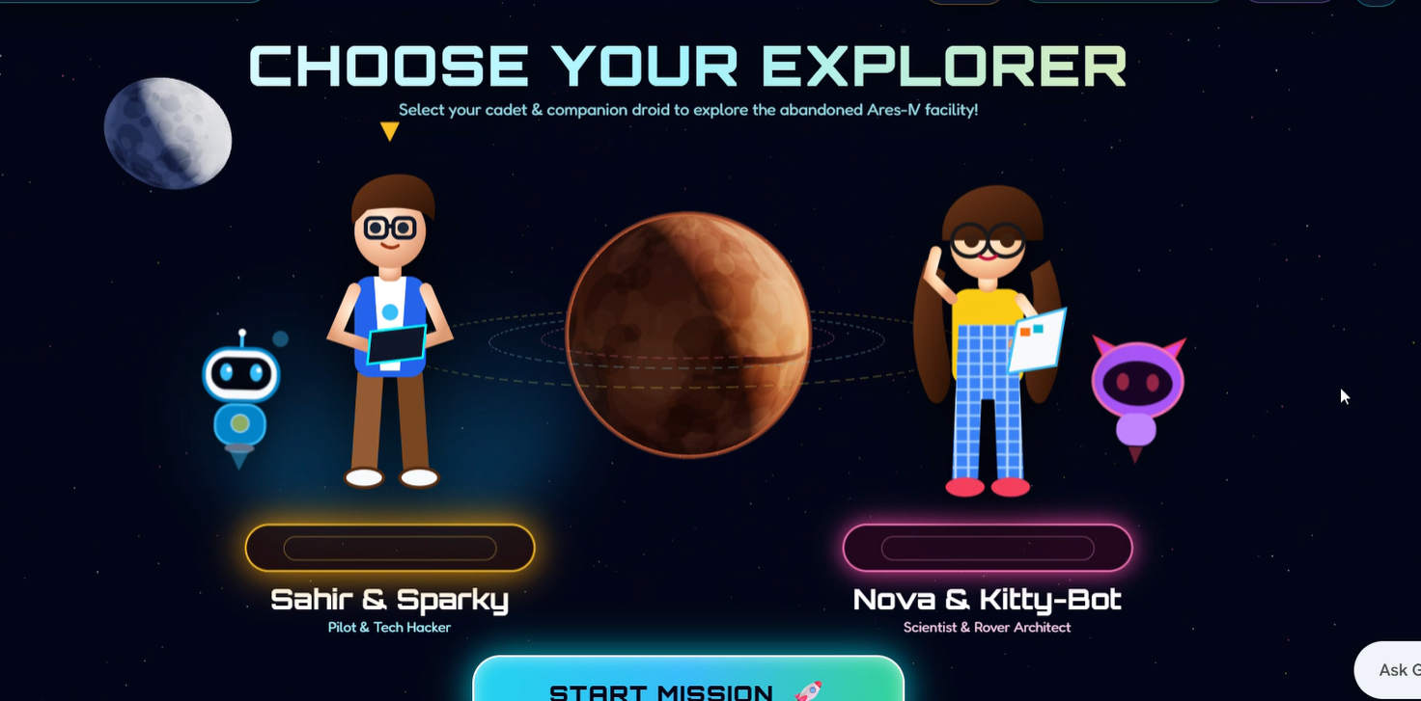

6.The main background will be 3d just like this (ref-whatsapp video)
7.Explorer selection just as shown
-character style ref- https://www.pinterest.com/pin/521432463128810103/
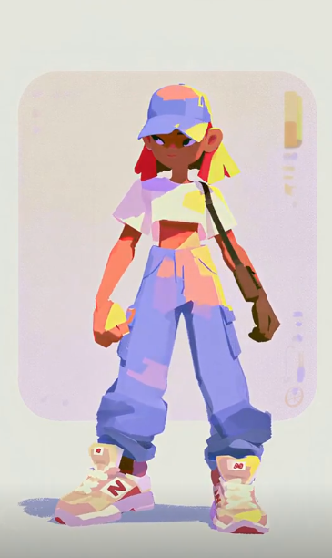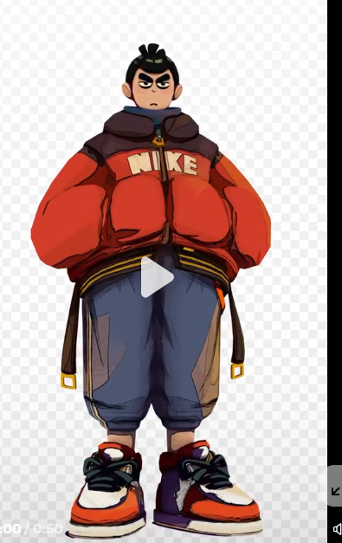

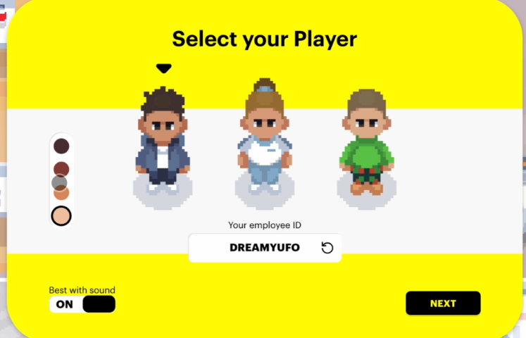 -User can write their name
-there will be 2 individual section ( one for explorer selection and then one for kitty selection)

8.kitty selection (there will be only image of different type of kitty so that player can just click the select option and the game will start)

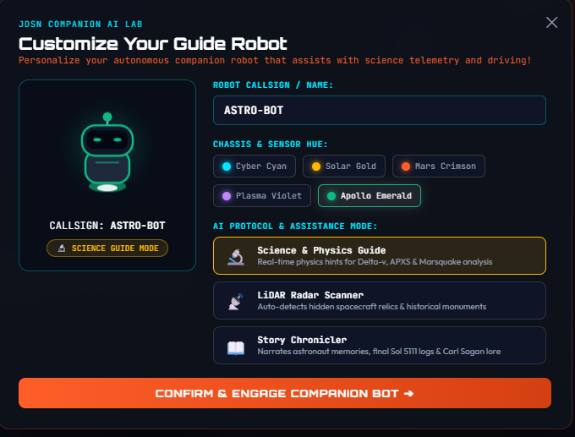

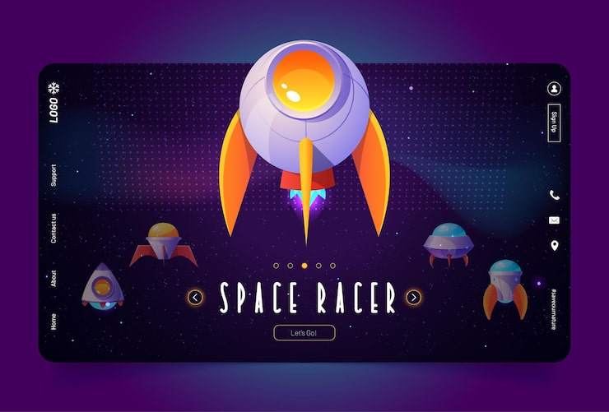 selection model (when player will select kitty .selected one will be large and rest will be small as shown in the picture)

9. left side will have game name
10. in middle there will be 1000 coin and 10 gems at initial phase.

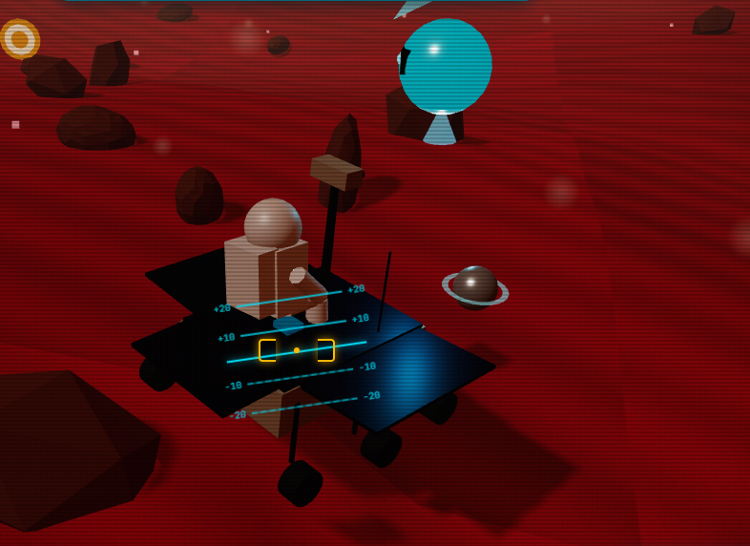

11. match character and kitty as selected by the user and there will be one kitty to guide.and there will be no blue line above the rover.
 12. This type of textual direction or guidance will be shown above the kitty and the kitty will talk this out loudly.

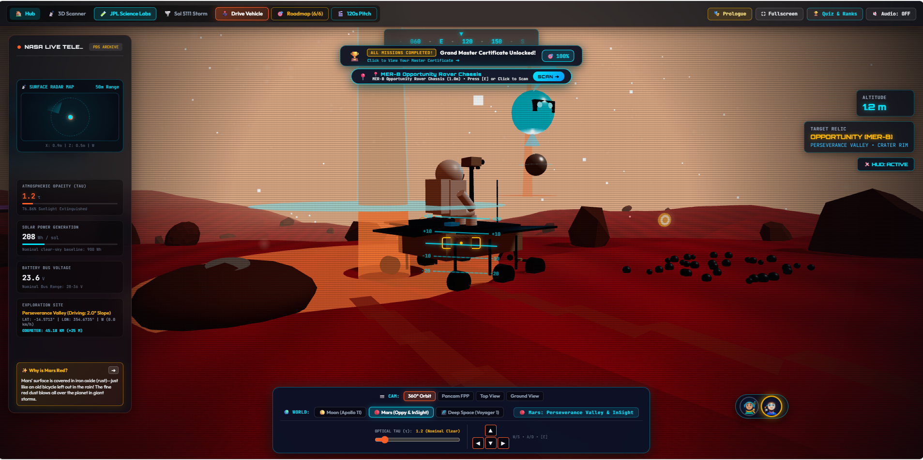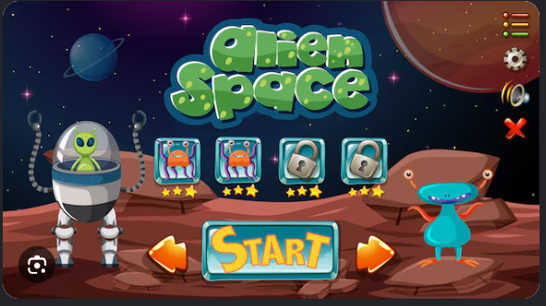

13. full screen will be at the front and the player can switch or exit from the screen and see the other options.
13.1. there will be star,planet in far way.
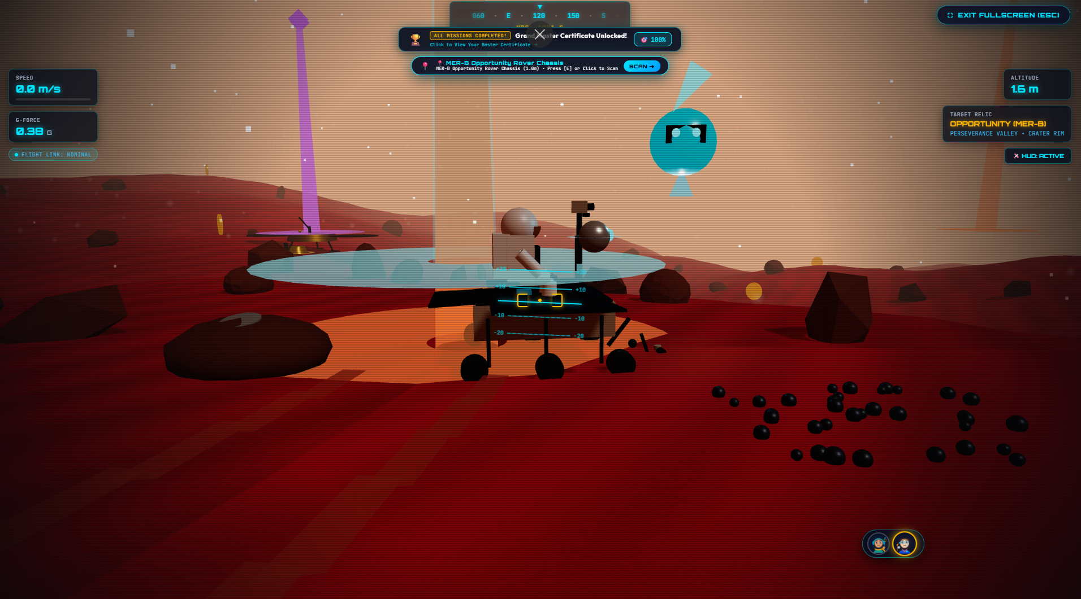
14. There will be a clear map where player can see other mission and players exact position(so that player can easily understand their position and navigate properly).

14.1. There will be no character in the game screen . there will be a map for missions and in top side left or right will be collected coin numbers.
14.2. the map will also show the completed mission near the player . it will also show some pop up so that the player can understand that he has already completed the mission.

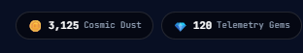

15. Mission and roadmap interface

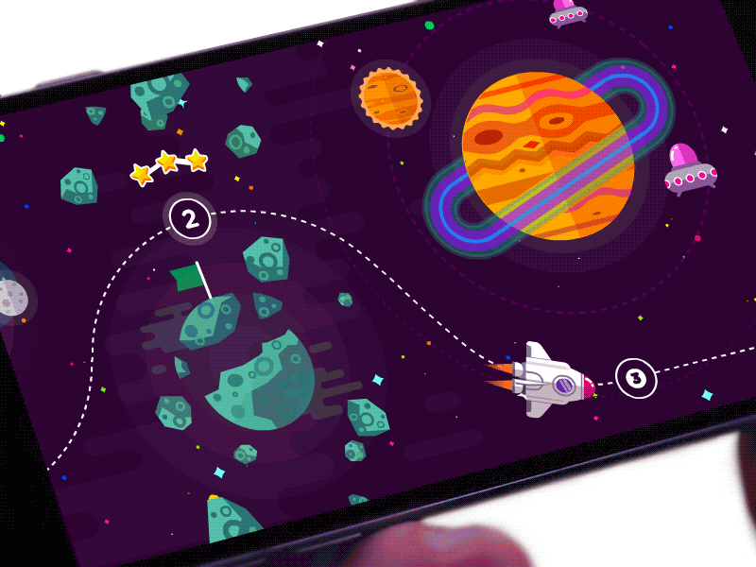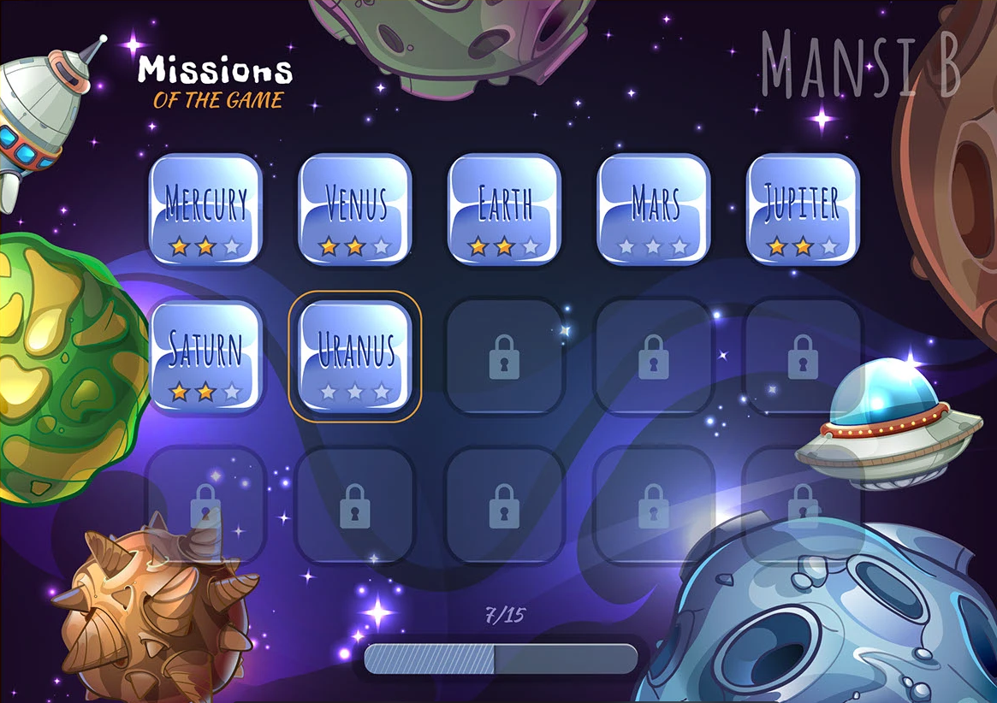

16. Add a leader board so that player feels excitement to see their position and merit position.(as multiple player play this in same time.)
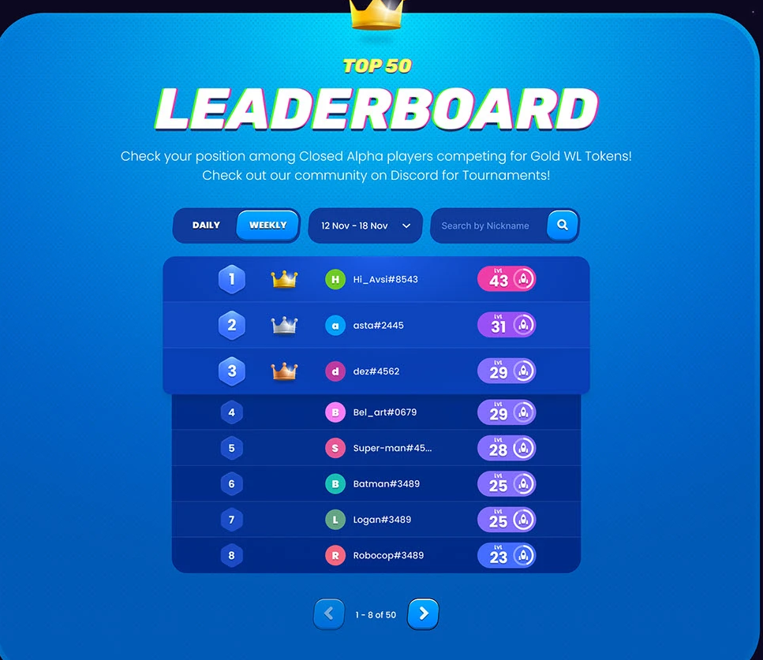

17. when a player complete a mission there will be a notification where it shows the great job message and 2 option play the quiz and proceed,
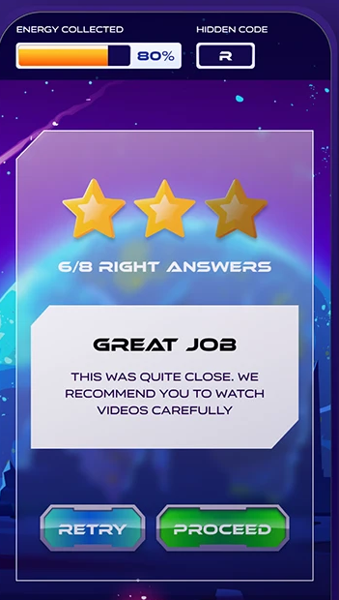
18.
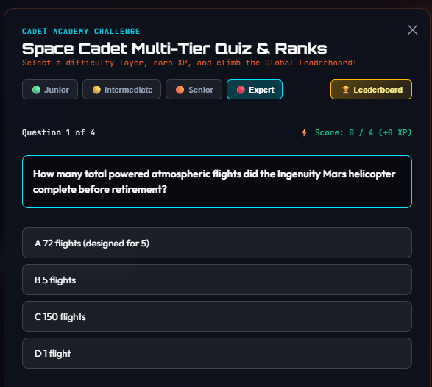
Here initially player can play junior quiz . other option will be locked.

19.
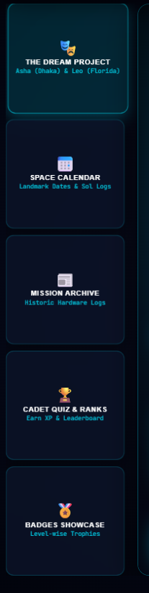 badge and showcase section will be certificate and badge section . integrated with level.

19.
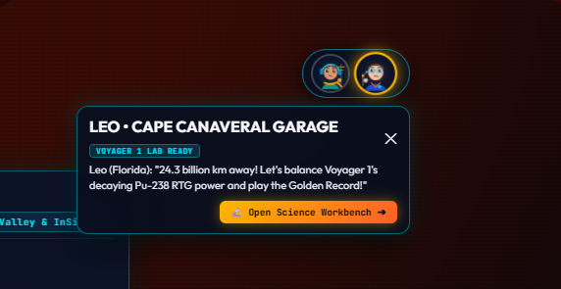
When the rover faces problem and

